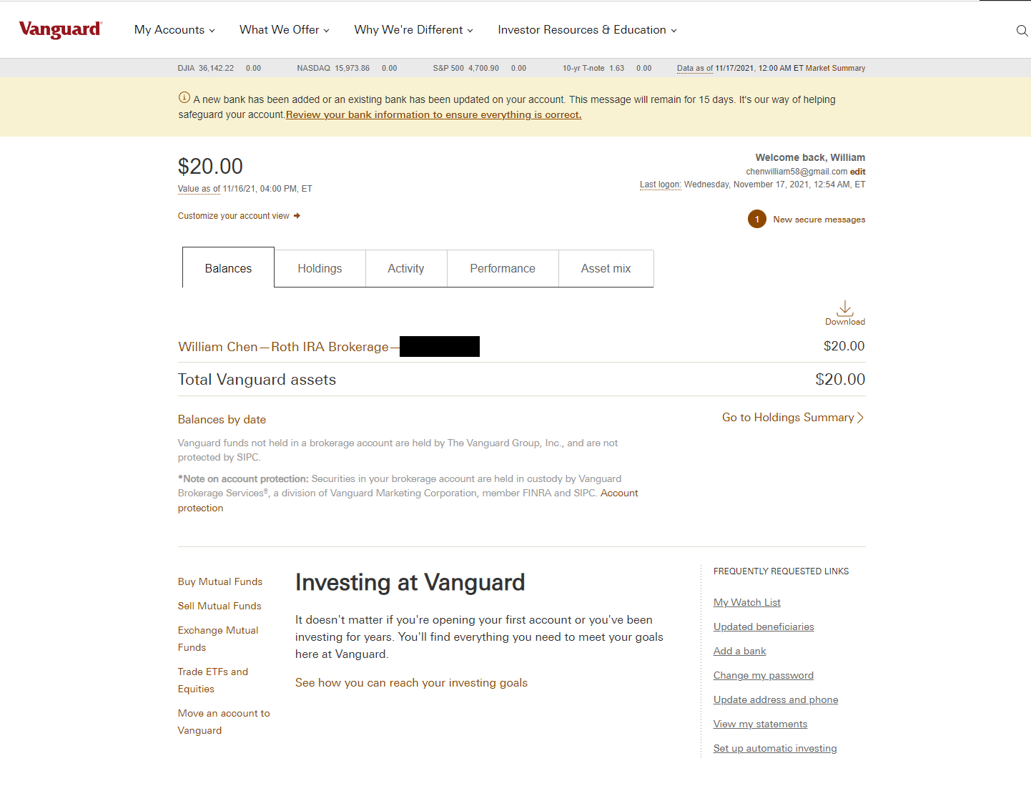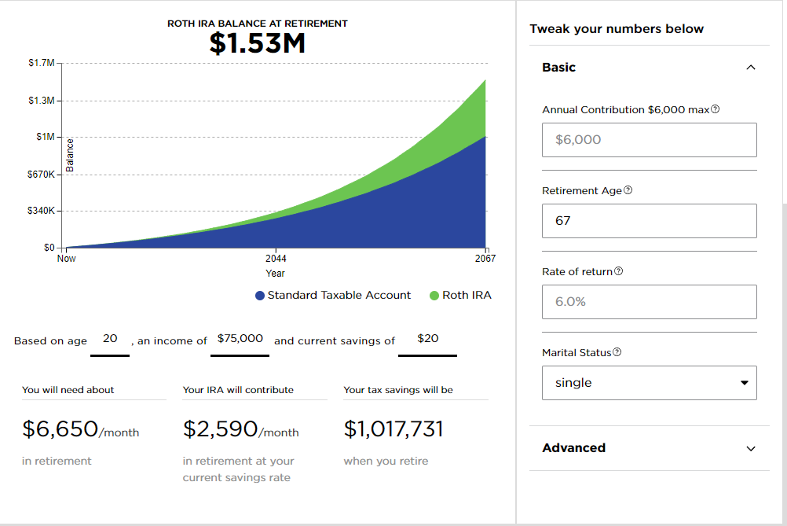

I decided to create a Vanguard account for my Roth IRA account because I heard it’s one of the best. In the Roth IRA calculator from NerdWallet, I stated my age and used the average income people earn in my field (information security). Additionally, my initial investment was $20 (as seen in the first screenshot). I was slightly surprised at how little a 47-year difference makes, but obviously, it isn’t entirely accurate since things can change between now and when I’m 67 years old.